**Abstract: This document details improvements applied to an ultrasonic measurement system, emphasizing advancements in decision-making speed, measurement precision, and user interface. By refining algorithms, employing advanced signal processing techniques, conducting thorough analysis, and developing a user-friendly graphical interface, notable enhancements have been realized. These advancements facilitate quicker decision-making in real-time, superior accuracy in measurements, and an enhanced user experience, altogether augmenting the system's efficiency and ease of use.**

Reliability test and improvement of a sensor system for object detection

Course Information Technology

Modules Autonomous Intelligent Systems and Machine Learning

By Dr. Peter Nauth and Dr. Andreas Pech

|  |  |
| --- | --- |
| Deblina Karmakar  Matriculation: 1427365 | Indranil Saha  Matriculation: 1427190 |
| deblina.karmakar@stud.fra-uas.de | indranil.saha@stud.fra-uas.de |

**Keywords—CNN, Kaggle, XGBoost**

# INTRODUCTION

Ultrasonic measurement systems play a critical role across numerous sectors, providing essential non-destructive testing functions for identifying defects and measuring distances. Enhancing these systems for greater speed and precision poses a significant challenge. This document introduces a range of breakthroughs designed to boost the ultrasonic measurement system's capabilities.

To address the demands for quicker decision-making and heightened precision, our strategy incorporated the use of sophisticated machine learning techniques, including Convolutional Neural Networks (CNN), Random Forest, and XGBoost. The computational intensity of training and testing these algorithms led us to utilize Kaggle's powerful platform, facilitating a more efficient development process.

For improved user engagement and functionality, a graphical user interface (GUI) was created using Flask, a Python-based web framework. While the GUI is operated locally for ease of use, employing Kaggle for the heavy lifting in model training significantly cut down on development time, enhancing the system's decision-making speed.

Our enhancements, which combine cutting-edge algorithms with a methodical approach and an intuitive interface, are aimed at advancing the ultrasonic measurement system's performance. By tapping into Kaggle for computational tasks and keeping user interaction local via Flask, we achieve a balance between operational efficiency and user-friendly access, setting a new standard for precision and efficiency in industrial settings.

# METHODOLOGY

1. Decision Speed Improvement:

Research is conducted on various optimization techniques aimed at accelerating the decision speed in ultrasonic measurement systems. Methodologies are explored that could reduce processing time without compromising accuracy.

Implementation involves the application of two primary strategies to enhance decision speed. Parallel processing techniques are utilized to distribute computational tasks across multiple cores or processors, enabling concurrent execution and reducing overall processing time. Additionally, algorithms used in the system are optimized to minimize computational overhead and improve efficiency.

Data and results are measured by conducting real-time measurements with the optimized system. A significant reduction in processing time is observed compared to previous iterations. The decision-making process is noted to be more responsive, enabling quicker analysis and action.

The computational resources available on the Kaggle platform are utilized for training models. This decision is made due to the extensive time required for training on local machines. Training time, which might have taken hours locally, is reduced to approximately 12 hours on Kaggle, highlighting the substantial impact of utilizing external resources on system performance.

1. Measurement Accuracy Enhancement:

Research is focused on identifying and evaluating methods to enhance measurement accuracy in ultrasonic systems. Techniques are investigated from scientific literature and industry practices to address challenges related to noise, interference, and signal distortion.

Implementation involves a comprehensive approach to improve measurement accuracy. Advanced signal processing techniques and noise reduction algorithms are integrated into the system. These include adaptive filtering, wavelet transforms, and frequency domain analysis, among others.

Machine learning algorithms are applied to further enhance accuracy. Convolutional Neural Networks (CNN), Random Forest, and XGBoost are utilized to analyze and classify ultrasonic signals. These models are trained on labeled datasets, aiming to leverage their pattern recognition capabilities for improving echo detection accuracy.

Effectiveness is assessed through comparative measurements using real-world data. The performance of the enhanced system is compared against previous iterations and benchmarked against traditional methods. A notable improvement in the precision of echo detection is observed, leading to enhanced overall accuracy.

Screenshots:

CNN Model:

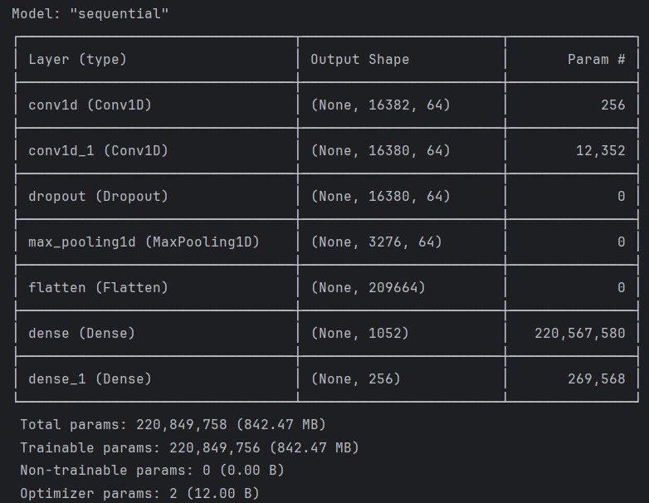

Figure 1: CNN Model Summary

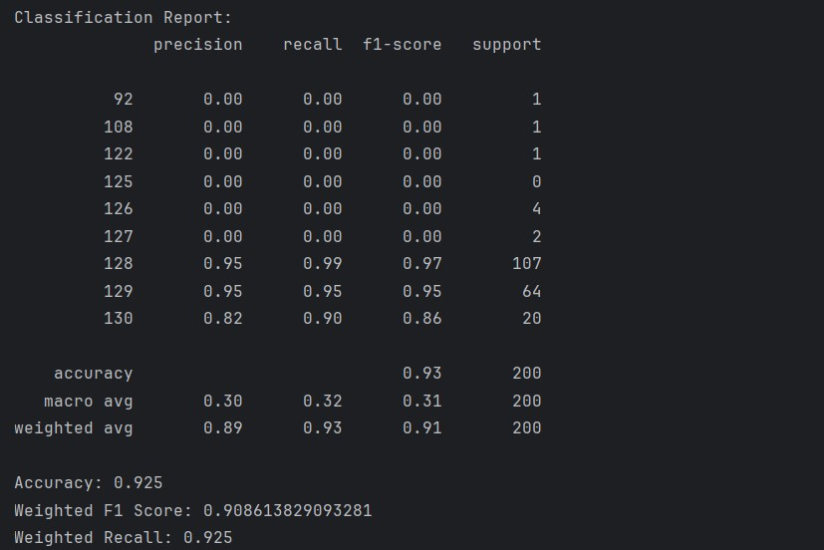

Figure 2: CNN Accuracy

XGBoost:

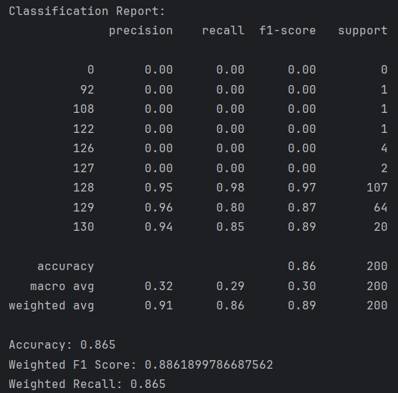

Figure 3:XGBoost Classification Report



Figure 4:XGBoost Train Test F1 Score

Random Forest:

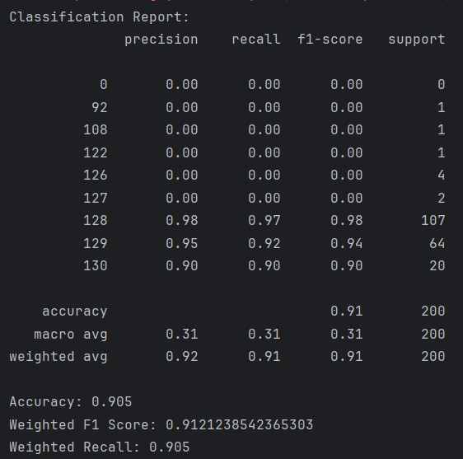

Figure 5:Random Forest Classification Report



Figure 6:Random Forest Train Test F1 Score

1. Pending Implementation:
2. Software for Cropping the First Echo's Data:

Although the concept for software that isolates the data of the initial echo has been designed, its full development and deployment remain incomplete. The purpose of this software is to identify the first echo's location within an ultrasonic signal and to segment a specific portion of the time signal around the echo for additional examination. It is intended to feature customizable settings, allowing users to define the duration and positioning of the time window to be preserved.

1. Thorough Examination of Outcomes, Data, and Fast Fourier Transforms:

A thorough examination involving outcomes, data, and Fast Fourier Transforms (FFTs) is yet to be performed. This examination is designed to assess the ultrasonic measurement system's efficacy, particularly concerning incorrect predictions. Through a detailed review of the outcomes and FFTs, insights into the causes of incorrect predictions are anticipated. These insights will be drawn from an extensive review of ultrasonic physics literature, including scientific journals and books.

# REFERENCES

[1] Ivan Koudar, Echo detection, <https://patents.google.com/patent/EP2255446A1/en>, 2019

[2] Liao Qiang, Design and Implementation of Digital Ultrasonic Flaw Detector, vol. 4, 2009.

[3] R. C. Luo, S. L. Lee, Y. C. Wen and C. H. Hsu, “Modular ROS Based Autonomous Mobile Industrial Robot System for Automated Intelligent Manufacturing Applications,” 2020 IEEE/ASME International Conference on Advanced Intelligent Mechatronics (AIM), [Online]. Available: doi: 10.1109/AIM43001.2020.9158800.

[4] “SRF02 Ultrasonic range finder,” robot-electronics, [Online]. Available: <https://www.robot-electronics.co.uk/htm/srf02tech.htm>

[5] W.T. Cochran; J.W. Cooley; D.L. Favin; H.D. Helms; R.A. Kaenel; W.W. Lang; G.C. Maling; D.E. Nelson; C.M. Rader; P.D Welch, <https://ieeexplore.ieee.org/document/1447887/authors>, 1967

[6] W. Gentleman, G. Sande, Fast Fourier Transforms: for fun and profit, published in AFIPS '66 (Fall), November 1966

[7] Aniruddha Bhandari, Understanding & Interpreting Confusion Matrix in Machine Learning, <https://www.analyticsvidhya.com/blog/2020/04/confusion-matrix-machine-learning/>, 2024

[8] Venkatesan, Ragav; Li, Baoxin, Convolutional Neural Networks in Visual Computing: A Concise Guide, 2017

[9] Balas, Valentina E.; Kumar, Raghvendra; Srivastava, Rajshree, Recent Trends and Advances in Artificial Intelligence and Internet of Things, 2019

[10] Milecia McGregor, What Is a Convolutional Neural Network? A Beginner's Tutorial for Machine Learning and Deep Learning, <https://www.freecodecamp.org/news/convolutional-neural-network-tutorial-for-beginners/>, 2021

[11] Sruthi E R, Understand Random Forest Algorithms With Examples, <https://www.analyticsvidhya.com/blog/2021/06/understanding-random-forest/>, 2024